DocCare

UI Prototype

Version 1.1

Revision History

| **Date** | **Version** | **Description** | **Author** |
| --- | --- | --- | --- |
| 15/12/2023 | 1.0 | The initial version of the document | All Members |
| 16/12/2023 | 1.1 | Update the flow on the customer scheduling | Phat Tran |
|  |  |  |  |
|  |  |  |  |

Table of Contents

1. Use-case 1: Schedule an appointment 4

2. Use-case 2: Receptionist Handles Offline Booking 8

3. Use-case 3: Doctor Handles Appointment 14

4. Use-case 4: Customer View Prescriptions And Rating Intake 18

5. Use-case 5: Admin Generate Monthly Report 22

6. Use-case 6: Absent requests management 25

# Use-case 1: Schedule an appointment

This prototype demonstrates the flow of use-case 2.24 in the Use-case Specification Document

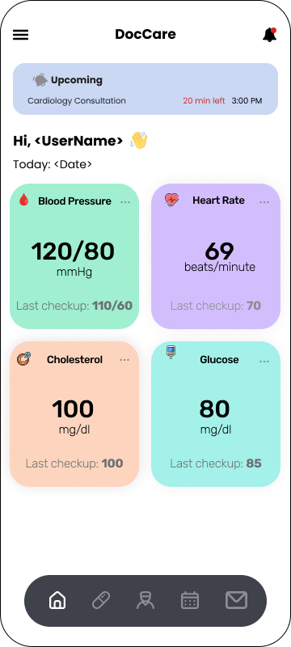

Starting from the home screen, you can either:

1. tap on the doctor button on the navigation bar to select the doctor before booking, or
2. tap on the schedule button next to it to go straight to the booking screen in case you do not know whom you should pick.



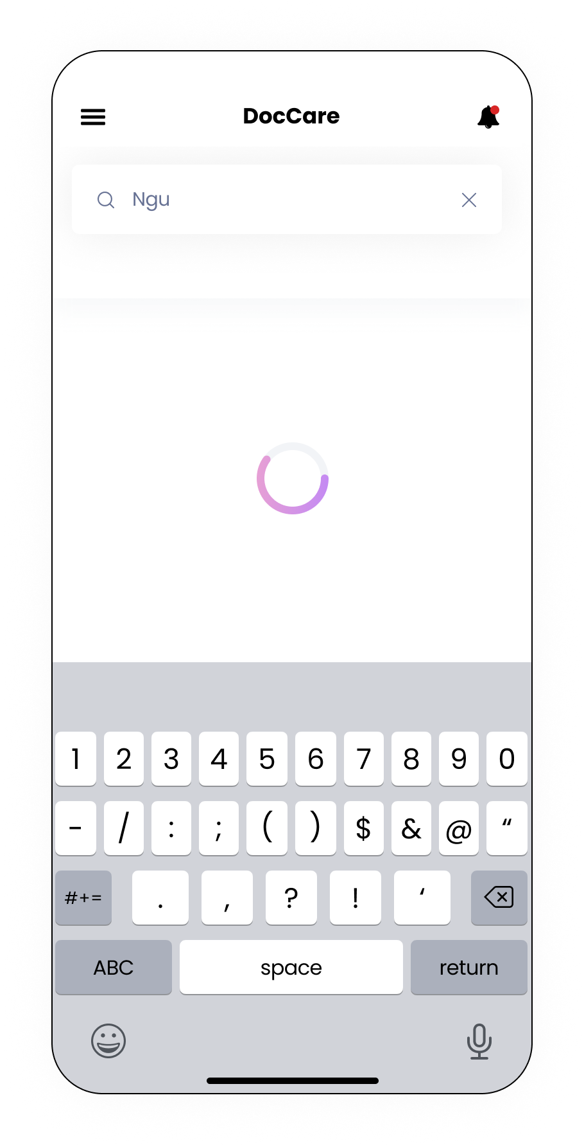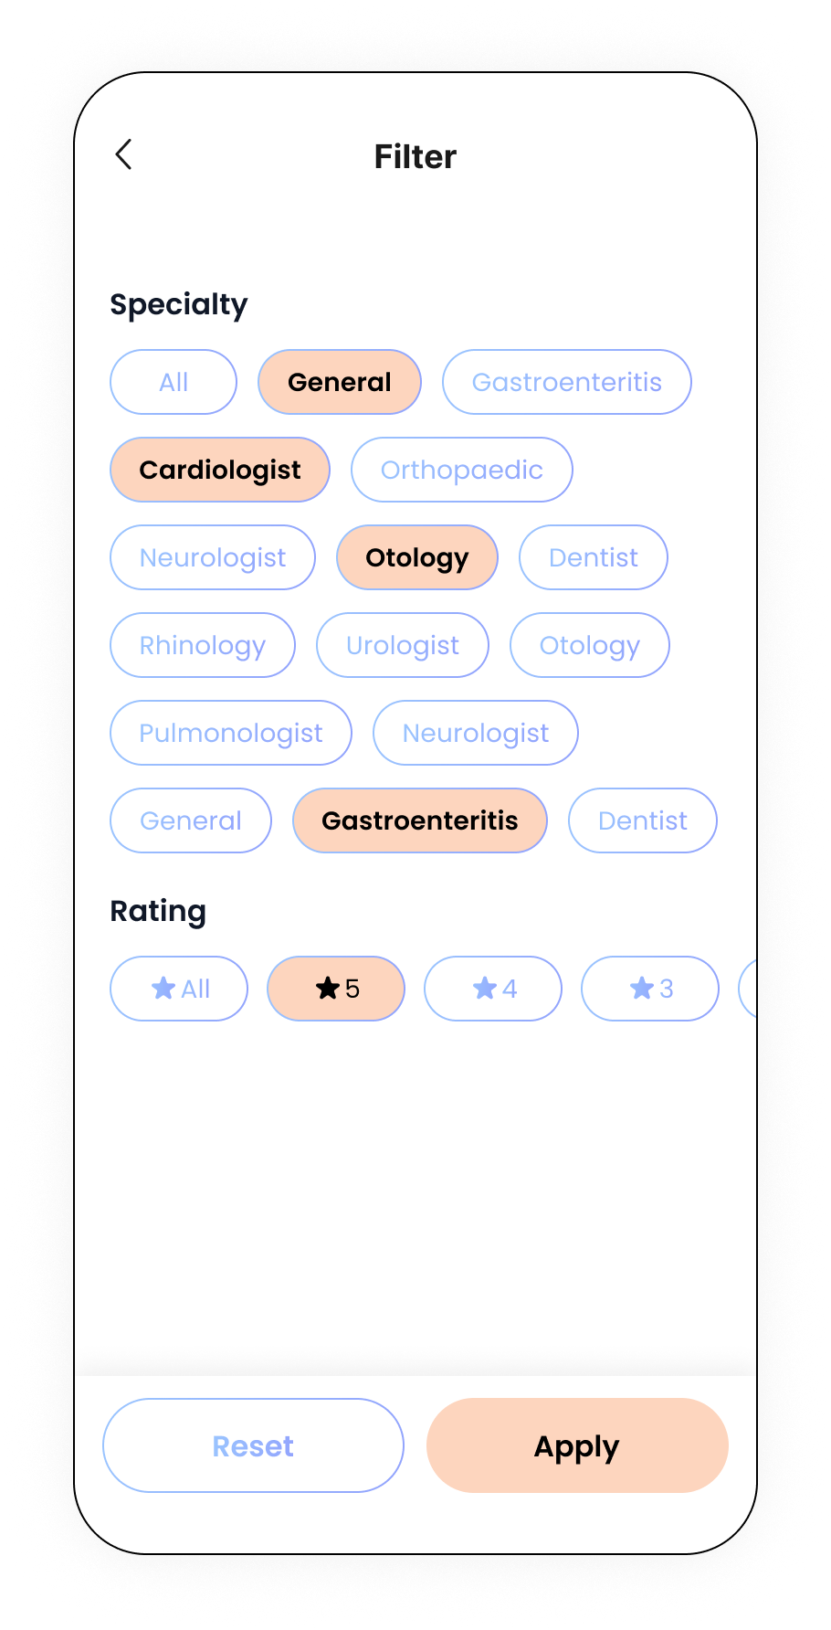

If you want to search for the doctor before booking, it will go to the Search for Doctor screen. Here, you can see the list of the clinic doctors together with their ratings and reviews.

1. If you want to search for some criteria only, tapping on the filter icon the the top right corner of the screen, below the notification icon. You will go to the filter screen where you can choose the specific ratings and specialization. Clicking the Apply button will automatically navigate to the previous screen and filter with your options. However, clicking the back button on the top left corner will navigate back without filtering anything.
2. You can also search for the doctor’s name in the search bar.

After having decided whom you want to book, tapping on the doctor’s card to choose, then you will be redirected to the booking screen.

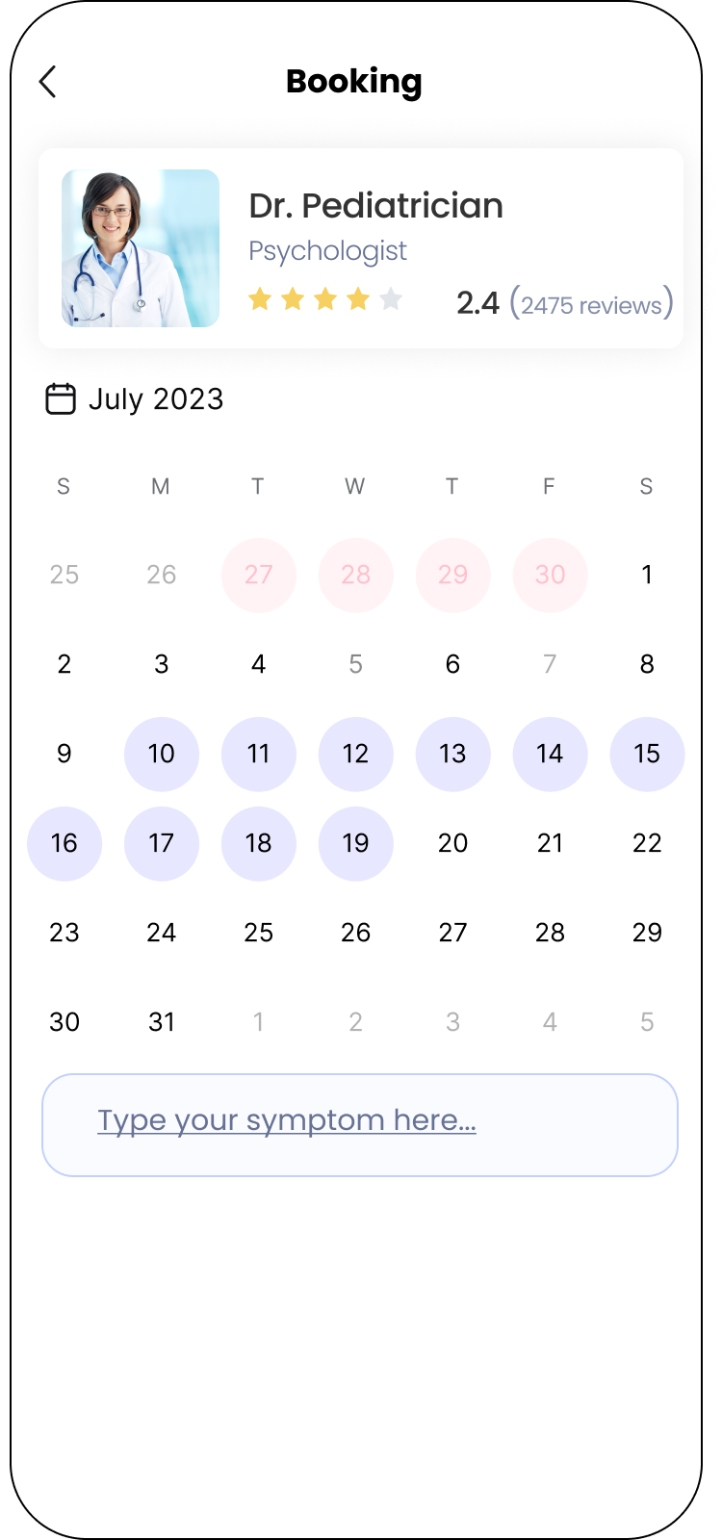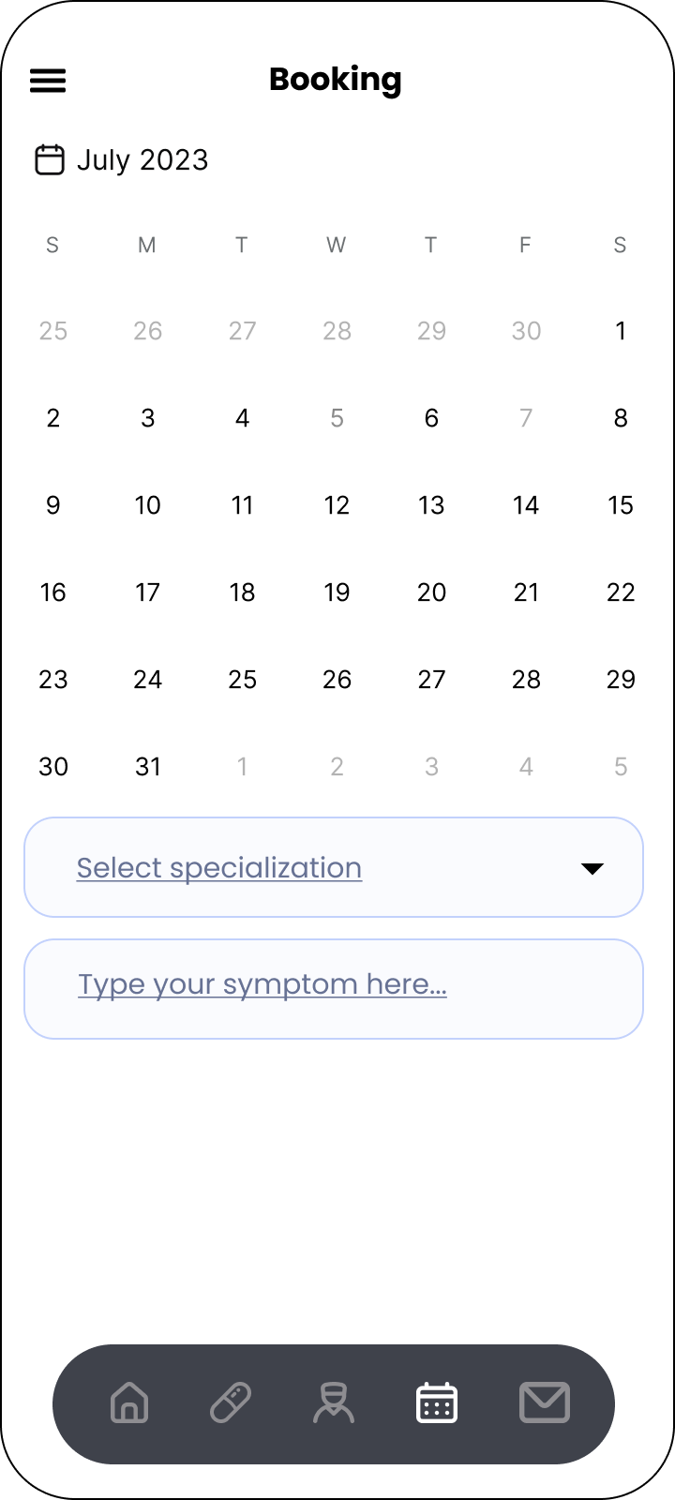There are 2 kinds of booking screens here:

1. The left one is when you have selected a doctor
2. The right one is when you have tapped on the schedule icon on the navigation bar to go straight to this screen as you do not know whom to pick.

The two screens contain similar information except for the latter one as it requires the patient to select the specialization that he/she wants to book a doctor by tapping on the dropdown button and selecting the desired one.

In these screen, they contain:

1. The doctor’s information, if the patient initially selects, as a card
2. The current month and year
3. The schedule on the body of the screen with:
   1. The red dates are the ones that are behind the current date but still are the working days of the doctor
   2. The purple ones are the available working dates
   3. If you go straight to this screen without choosing a doctor, the schedule is empty.
4. The input field for you to enter your symptoms. This is optional.

You can select a date by tapping on it.

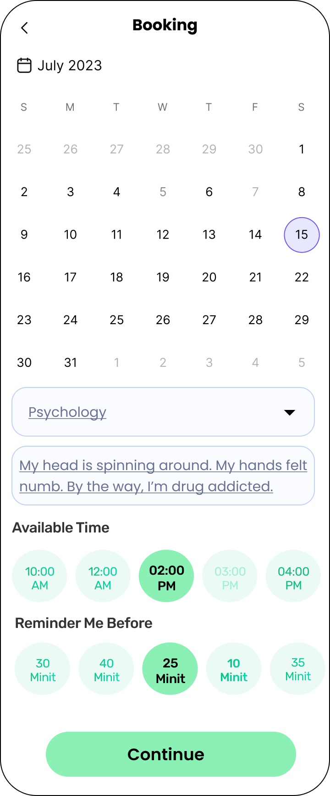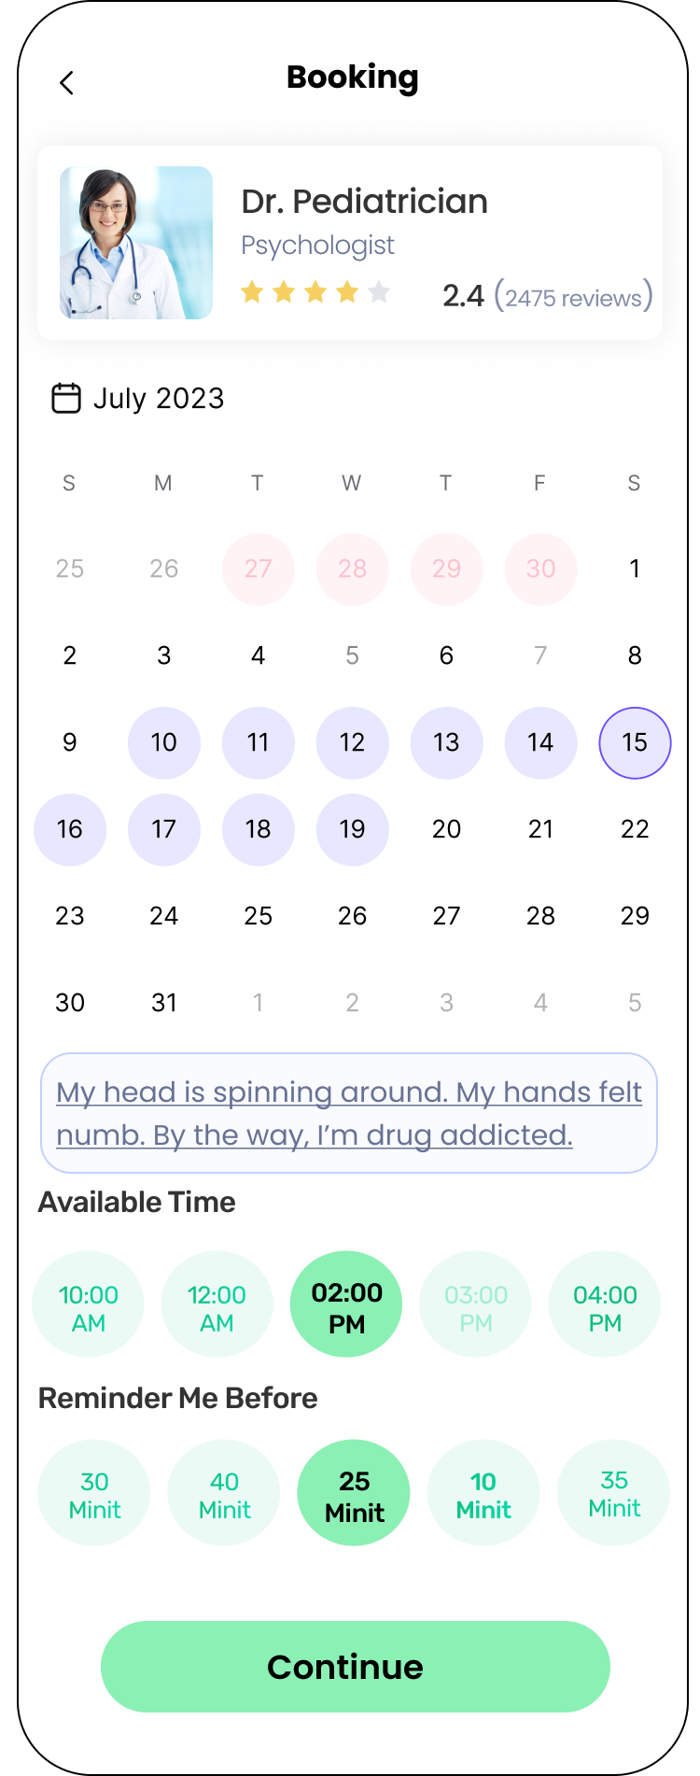After selecting a date, the application shall proceed to show the available time left for the patient to choose together with the option to remind you before. In the available time section, the one which is blur is initially booked by someone else. You can select the time by tapping on it. Finally, after everything is okay, you will click on the continue button.

After clicking on the continue button, we will navigate you to the confirmation screen. Here, you can see the details of your booking including: the date, time, symptoms and the doctor name.

If you tap cancel, you will be back to the previous booking section with the initial information, without any loss.

If you tap confirm, the system will then process your request. If successful, we will alert you with the Thank You dialog; tapping on the Okay will navigate you back to the home screen. If you fail, we will alert you with the Opps dialog.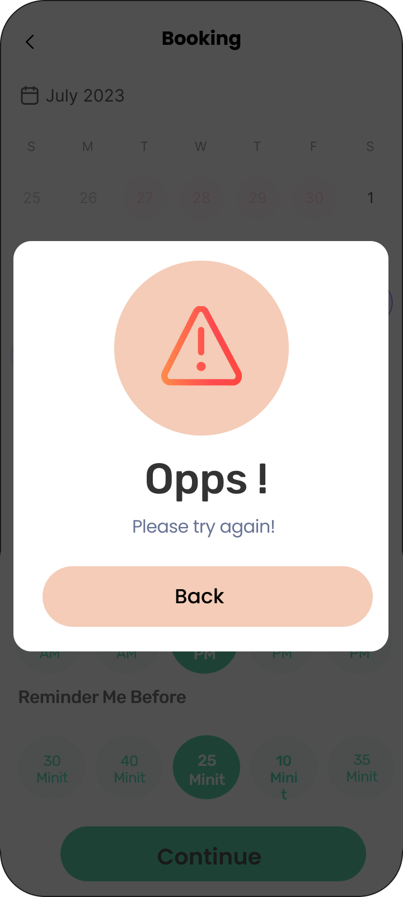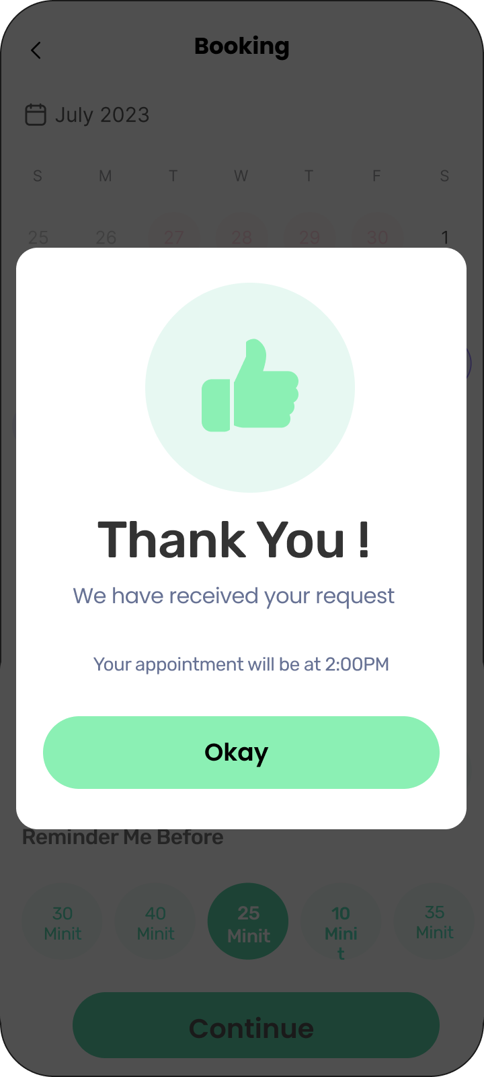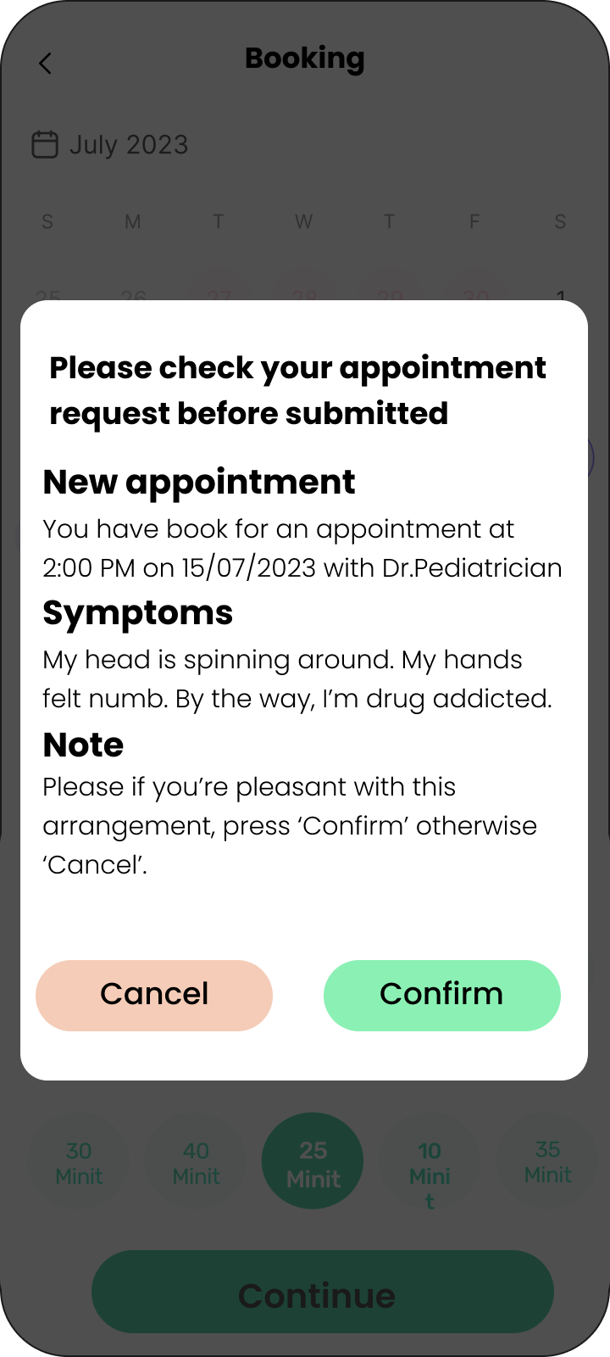

# Use-case 2: Receptionist Handles Offline Booking

This prototype demonstrates the flow of use-case 2.11 in the Use-case Specification Document

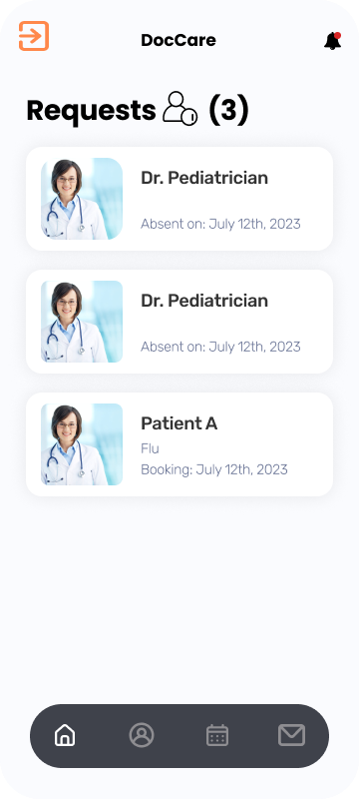

**Receptionist’s home screen**

This is the screen where the receptionist is landing when already authenticated. The bottom navigation bar will support move to other different functionality screens. Receptionists now can tap on the ‘calendar’ icon of the bottom navigation bar to move to the Schedule screen.



**Receptionist’s doctor choosing screen**

In this screen, there would be some default doctors to choose or the receptionist can type in a name to search for his/her offline patient’s desired doctor. Receptionists must choose a specific doctor for offline patients because they are the managers who know the most about specialized doctors.

To find information effectively, receptionists can filter doctors with a ‘Category’ filter right above the name text field and clicking on that icon will lead to the right filter selection screen.

After choosing the appropriate doctor, tap on that doctor.



**Appointment day selection**

This day's selection screen will be after the choosing doctor screen. And this screen will include:

1. The doctor’s information, if the receptionist initially selects, as a card
2. The current month and year
3. The schedule on the body of the screen with:
   1. The red dates are the ones that are behind the current date but still are the working days of the doctor
   2. The purple ones are the available working dates
4. The input field for the Receptionist to enter the patient's symptoms. This is optional.

receptionist can select a date by tapping on it.

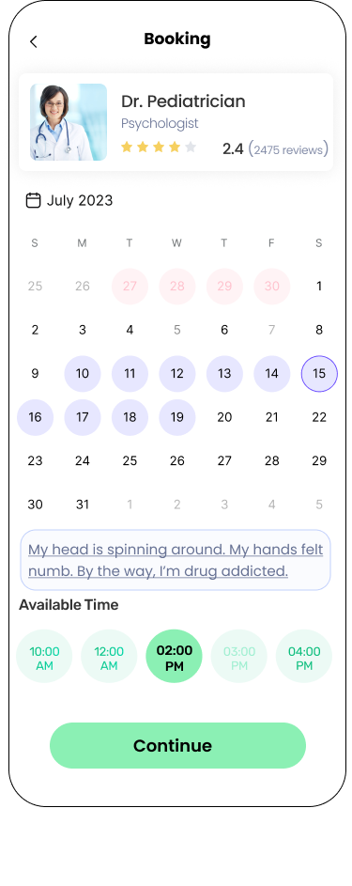

**Appointment time selection**

After selecting a date, the application shall proceed to show the available time left for the receptionist to choose. In the available time section, the one which is blur is initially booked by someone else. Receptionist can select the time by tapping on it. Finally, after everything is okay, the receptionist will click on the continue button.



After clicking on the continue button, the system will navigate the receptionist to the confirmation screen. Here, the receptionist can see the details of your booking including: the date, time, symptoms and the doctor name.

If the receptionist taps cancel, he/she will be back to the previous booking section with the initial information, without any loss.

If the receptionist taps confirm, the system will then process your request. If successful, the system will alert the receptionist with the Thank You dialog; tapping on the Okay will navigate the receptionist back to the home screen. If the receptionist fails, the system will alert the receptionist with the Opps dialog.

# Use-case 3: Doctor Handles Appointment

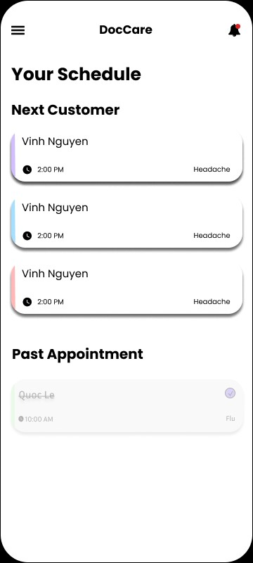

**Doctor’s Schedule Screen**

This is the screen displaying the schedule throughout the day for the doctor. There will be a list of appointments, together with the name of the patient and the time of the appointment. The doctor can tap on the widget to be navigated to another screen, where the doctor can check the medical stats and give prescriptions to the corresponding patient.

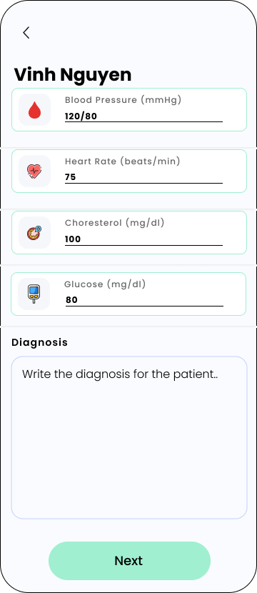

**Checking Medical Stats Screen**

On top of this screen will display the name of the patient. The doctor can type in the medical stats of the patient for diagnosing purposes by tapping on the input field, and type the data according to the format of that stat. After that, the doctor will give a medical diagnosis by typing into the textbox. After finishing, the doctor can tap on the “Next” button to be directed to the screen to give prescriptions.

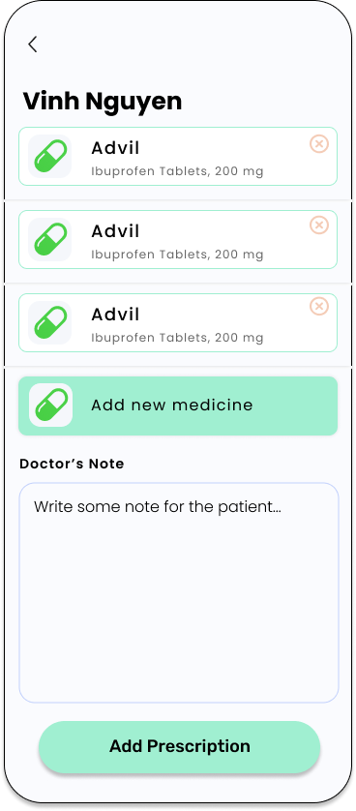

**Giving Prescriptions Screen**

This is the screen where the doctor can give prescriptions to the patient. At first, there will be no medicine, only the “Add new medicine” widget is displayed. The doctor can tap the “Add new medicine” widget to add a medicine to the widget. Every time a new medicine is added, it will be displayed on the widget. The doctor can write some notes about the medicines in the textbox. After the doctor is finished, he/she can tap the add prescription button, and it will add the prescription to the data of the patient.

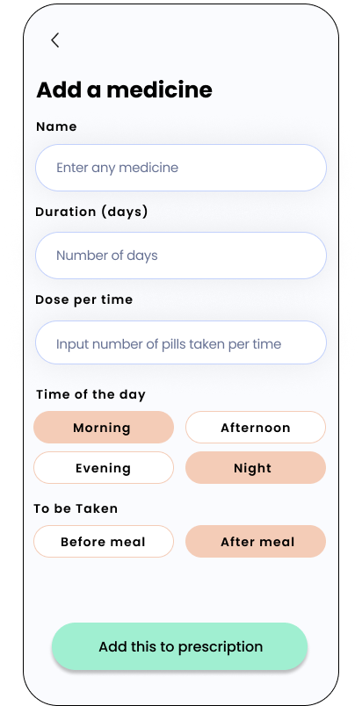

**Add Medicine Screen**

This screen is where the doctor can add the suitable medicine for the patient. After filling out the necessary information, the doctor can tap the “Add this to prescription”, which will add the medicine to the prescription list and the doctor will be navigated to the “Giving Prescription Screen” above to continue the process.

# Use-case 4: Customer View Prescriptions And Rating Intake

This prototype demonstrates the flow of use-case 2.8 and 2.13 in the Use-case specification document

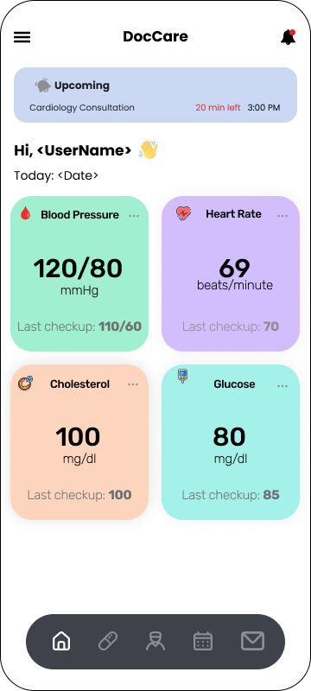

**Customer’s Home Screen**

From the home screen, tap the pill icon on the bottom navigation bar to move to the prescription history screen.

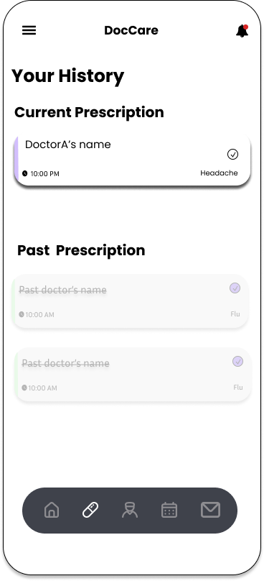

**Prescription History Screen**

Here, the user can check their current and past prescription. Here, they can see the overview information about their last few prescriptions: the date where it was prescribed, their symptoms, and the doctor who prescribed it. Then, tapping on items of either section will navigate the user to the medicines screen.

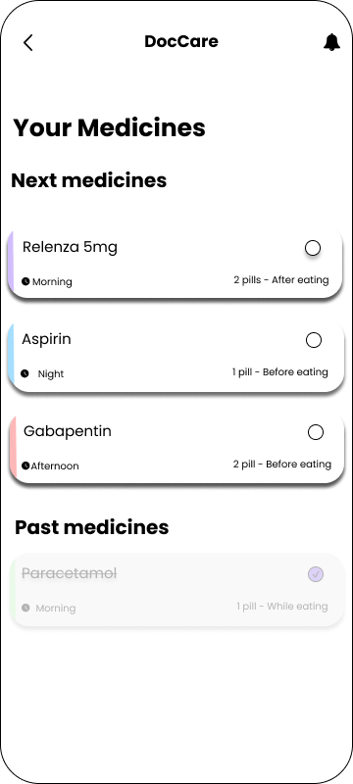

**Medicines Screen**

In this screen, the user can see all of the medicines that need to be taken during the day. Medicines that have been consumed will be moved to the past medicines section. The user can also manually move the medicine to the past medicines section by tapping on the tick box if they don’t want to get a notification for that particular medicine.

Tap the back button to move back to the prescription screen and select another one if the user wants to

Tap an item on this screen to show a pop-up which will let the user see the full details of the intake.

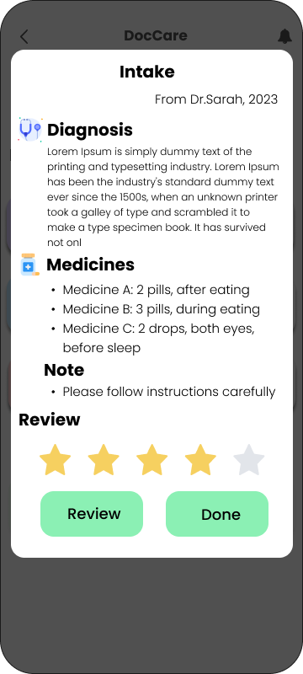

**Intake Details Screen**

On the pop-up, the user will see the full diagnosis of the doctor, medicines, and the doctor’s note.

Tap on the “Done” button to return to the medicines screen.

If the user wants to rate their last appointment, tap a star in the second to last row on the screen. From left to right, the star will indicate how well the user thinks the service was (from 1 star being the lowest to 5 star being the highest). After settling with the rating, the user can now tap the “Review” button. The rating will be processed in the background, the pop-up will be closed and the user can continue to use the app as normal.

# Use-case 5: Admin Generate Monthly Report

This prototype demonstrates the flow of use-case 2.14 in the Use-case specification document

Upon logging in, the admin will be directed to the admin menu screen, which provides various options:

* Within the admin menu, the admin chooses the specific option labeled "Generate Report" to initiate the report generation process.

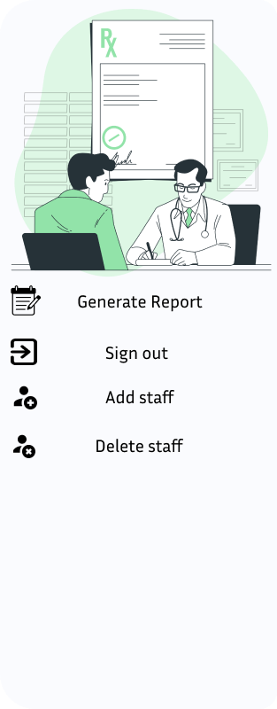

**Admin menu screen**

* Upon selecting "Generate Report," the admin is directed to the report generation screen, which facilitates the customization of the report.
* On this screen, the admin inputs the desired duration for the report. This involves:
* Choosing the start month from a dropdown menu.
* Selecting the end month from another dropdown menu.
* Inputting the year for which the report needs to be generated.

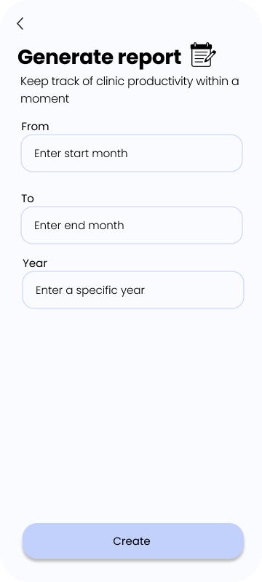

**Report generation screen**

* The app generates a comprehensive PDF report consisting of multiple pages.
* Each page within the PDF corresponds to a specific month within the selected duration.
* The report includes detailed statistics, numerical data, and graphical representations relevant to the clinic's business for each month covered.

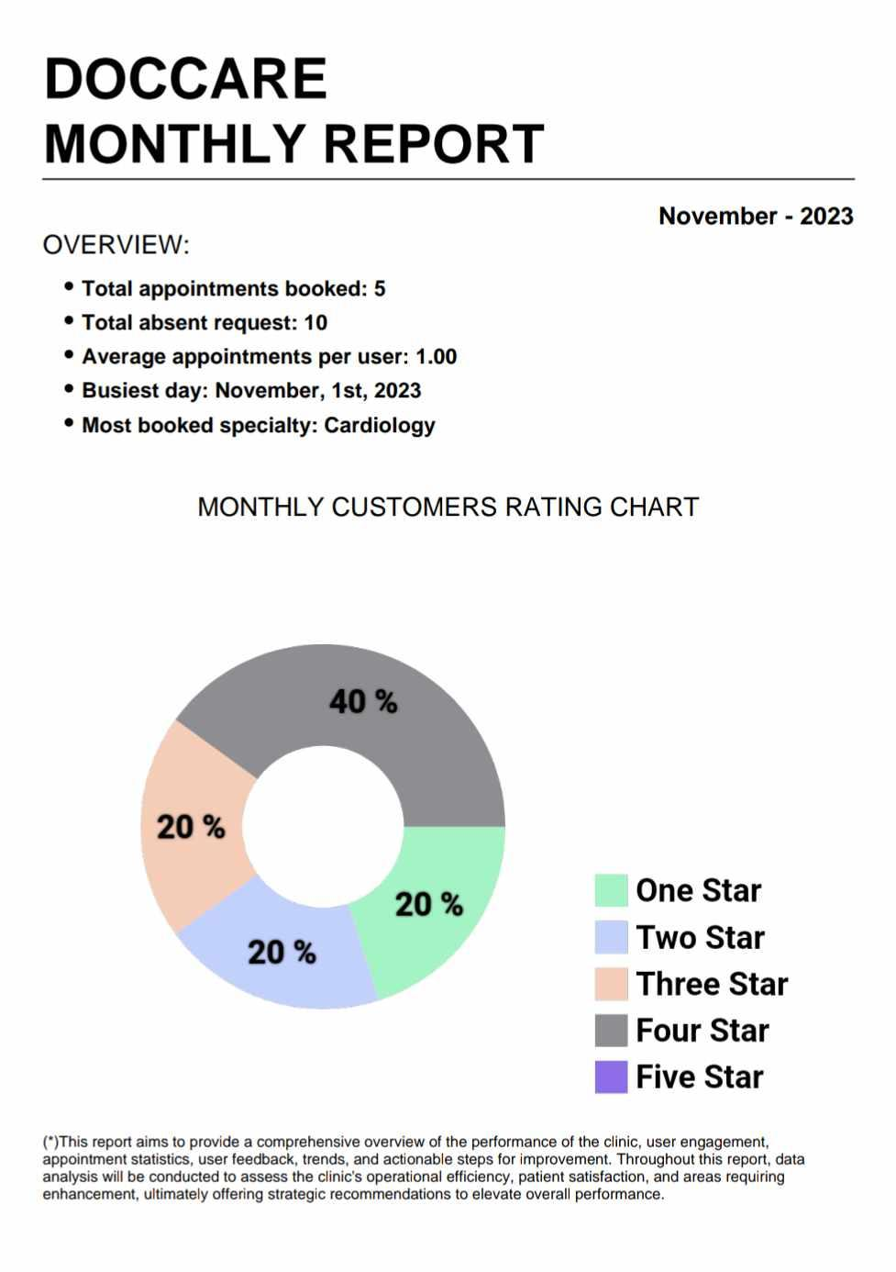

**Monthly Report Pdf File**

# Use-case 6: Absent requests management

# This prototype demonstrates the flow of use-case 2.7 and 2.16 in the Use-case specification document

* Firstly, with doctor ‘[Send absent request](https://docs.google.com/document/d/1croQz4-Epp-P2RJYWWPvELU5x7fGA1kM/edit#heading=h.bzqi8hxngrjx)’:

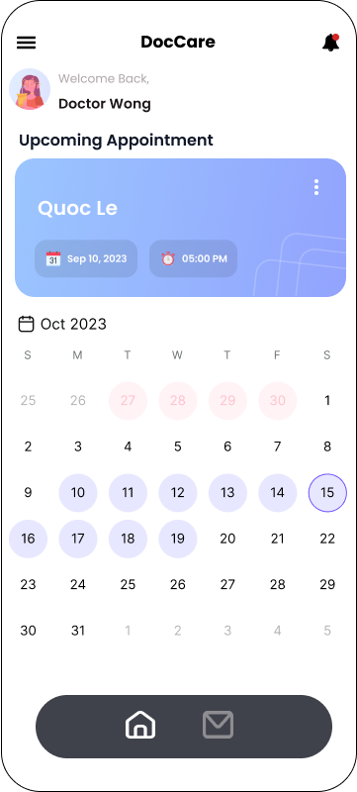

**Doctor home screen**

The doctor is navigated to the Home screen after authentication.

1. Then tap on the desired day where he/she wants to cancel.
2. After choosing, the day chosen will be rounded by a bold purple border then Doctor tap on the ‘Upcoming Appointment’ section.

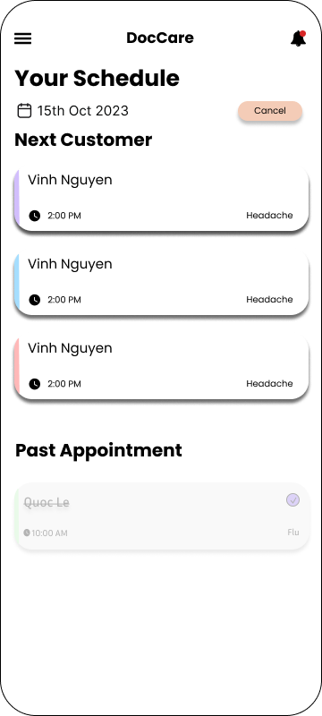

**Appointment of selected day**

Here the screen will include:

1. List out all the appointments on that day of the doctor, it also displays the day which he chose to cancel on the top.
2. A separate screen will show his/her next appointments (if having) and past appointments (if having, ex. today,..) during that day.

Doctor shall tap on the ‘cancel’ button to request absence on that day to the receptionist.

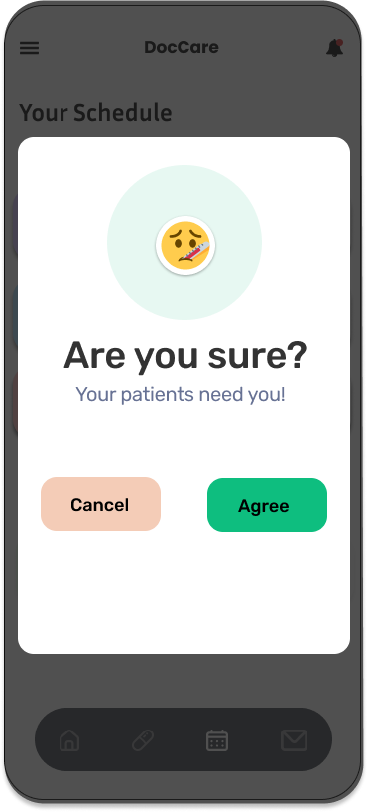

**Confirmation pop up**

The pop up immediately appears to confirm again whether the doctor wants to be absent on that day. There would be 2 selections:

1. If he/she taps on Agree, then the request would be sent to the receptionist to handle and navigate him/her to the home screen.
2. If he/she taps on Cancel, then the pop up will disappear and back to the laid down screen.

* Later, a response by Receptionist ‘[Handle Doctor Absent Request](https://docs.google.com/document/d/1croQz4-Epp-P2RJYWWPvELU5x7fGA1kM/edit#heading=h.2et92p0)’



**Receptionist’s home screen**

At home screen of receptionist after authentication, there may be some pending absent requests from doctors on the screen, each will have:

1. The name of the doctor
2. The day that doctor want to be absent on

Then the receptionist can select a specific absent request to review its details.

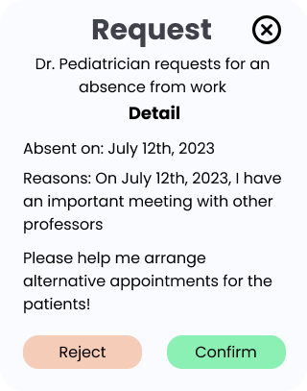

**Absent request detail pop up**

Here is the detailed pop up of the selected request, it include:

* System presents details of the absent request including the doctor's name, date(s) of absence, reason, and any additional notes provided.
* Receptionist evaluates the request and decides to:

a. Approve the absence:

i. Receptionist selects the option to approve the absence request.

ii. System updates the doctor's schedule accordingly, marking the requested dates as absent.

iii. System notifies the doctor about the approved absence.

b. Dismiss the absence request:

i. Receptionist selects the option to deny the absence request.

ii. System retains the doctor's regular schedule without marking the requested dates as absent.

iii. System notifies the doctor about the dismissal of the request.

c. Temporary not handle:

i. Receptionist selects the ‘x’ to exit the popup.

ii. This won’t make any changes to the system as well as this request is still pending

* System updates the status of the absent request (approved/dismissed).
* Receptionist is redirected back to the list of pending absent requests.